# ABSTRACT

THE CAR SOFTWARE SYSTEM IS AN ACCOUNTS BASED USER FRIENDLY GUI )GRAPHICAL USER INTERFACE( SOFTWARE,THAT HAS HIGH LEVEL OF ABSTRACTION FUNCTIONALITIES IN ACHIVEMENT OF BROKRAGE WORK IN CAR TRADING AND COMMUNICATION

INTRODUCTION

The car buying process is making a huge shift to digital, meaning car dealers need to adapt and recreate the experience of the dealership online to cater to the digital customer. To better equip themselves, buyers are going online, at an astounding rate of 83%, spending an average of 18-19 hours researching before making a vehicle purchase. And as the industry shifts, consumers’ online activity, including consumer research, interactions with salespeople and actual purchases and sales of vehicles, is growing at an overwhelming rate.

If dealers fail to create an online presence to effectively interact with today’s customers, they lose the opportunity to put their dealership in front of over half of those individuals looking to purchase a vehicle The internet’s arrival and its subsequent popularity in India have made online trading in India, which is about the online purchase and sales of shares, one of the extremely popular means of trading. Both beginner and experienced traders and investors in India are milking this opportunity by trading online in futures and options, stocks and currencies worldwide. Such opportunities are in the form of reduced brokerage and commissions, better broking services etc. Constructive uses of new technologies have always contributed positively towards improving human life standards and the economy of a country. Such as online trading, in equity markets it increased trade volumes and number of investors trading in stock markets.

Online trading was started in India in the year 1995, where a new system is formed which allows the investor to trade through an internet site where the major financial products and services like equities, mutual funds, life insurance, general insurance, loans, share trading, commodities trading, portfolio management and financial planning etc. are directly available for the customer. There is also stock option trading in India. An option is a financial agreement, with a predetermined maturity period and price, for the purchase or sales of the underlying products. Stock options enable the protection of dealers and control of their stocks, in addition to generation of higher earnings. For carrying out online trading in India,

you have to open a trading account, followed with online trading software. For this purpose, you would require a Depository Participant (DP), selection of which should be preceded by extensive research on various determinants.

This is time consuming and inefficient. This imposed limits on trading volumes and efficiency. In order to provide efficiency, liquidity, and transparency NSE and BSE introduced nationwide online fully automated system.

Online trading in India is the internet based investment activity that involves no direct involvement of the broker.

There are many leading online trading portals in India along with the online trading platforms of the biggest stock houses like the National stock exchange and the Bombay stock exchange.

The total portion of online share trading India has been found to have grown from just 3 per cent of the total turnover in 2003-04 to 16 per cent in 2006-07. Online The investor has to register with an online trading portal and get into an agreement with the firm to trade in different securities following the terms and conditions listed down on the agreement.

The order processing is done in correct timings as the servers of the online trading portal are connected to the stock exchanges and designated banks all around the clock.

They can also get updates on the trading and check the current status of their orders either through e-mail or through the interface.

Brokerages also provide research content on their websites, such that the clients can take their own decisions on stocks before investing.

In spite of many private stock houses at present involved in online trading in India, the NSE (National Stock Exchange) and BSE (Bombay Stock Exchange) are among the largest exchanges. They handle huge daily trading volumes, supporting large amounts of data traffic and processing a countrywide network. The automated online systems used for trading by the national stock exchange and the Bombay stock exchange are the NIBIS or NSE’s Internet based System and NEAT for the national stock

exchange and the BSE online trading system or BOLT for the Bombay stock exchange. Thanks to the ever-rising number of people owning computers along with a readily available internet access, online stock trading in India is simplified manifolds. This is because investments can now be easily controlled by traders themselves as a result of extensive availability of all types of information on the web.

# FEASIBILITY STUDY

A feasibility analysis usually involves a thorough assessment of the operational (need), financial and technical aspects of a proposal.

Feasibility study is the test of the system proposal made to identify whether the user needs may be satisfied using the current software and hardware technologies, whether the system will be cost effective from a business point of view and whether it can be developed with the given budgetary constraints.

A feasibility study should be relatively cheap and done at the earliest possible time.

Depending on the study, the decision is made whether to go ahead with a more detailed analysis.

When a new project is proposed, it normally goes through feasibility assessment.

Feasibility study is carried out to determine whether the proposed system is possible to develop with available resources and what should be the cost consideration.

Facts considered in the feasibility analysis were.

-1 Technical Feasibility

-2 Economic Feasibility

-3 Behavioural Feasibility

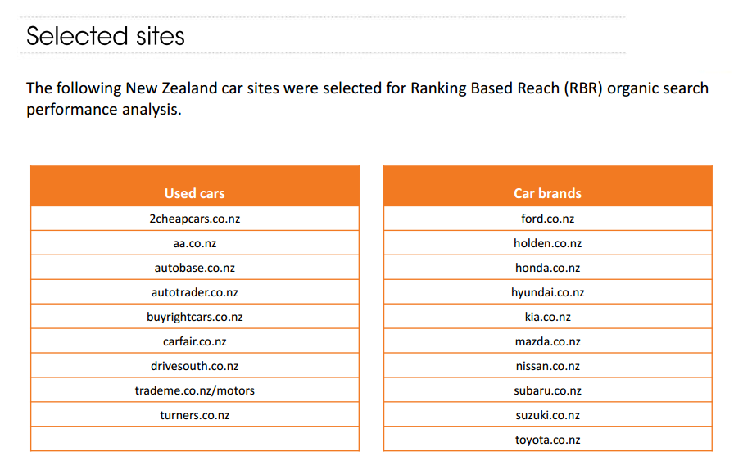

1- The Technical feasibility

Technical Feasibility Technical Feasibility deals with the hardware as well as software requirements.

Technology is not a constraint to type system development. We have to find out whether the necessary technology, the proposed equipment have the capacity to hold the data, which is used in the project, should be checked to carry out this technical feasibility.

issues usually raised during the feasibility stage of investigation includes these

• This software is running in windows 7 Operating System, which can be easily installed.

• The hardware required is Pentium based server.

• The system can be expanded

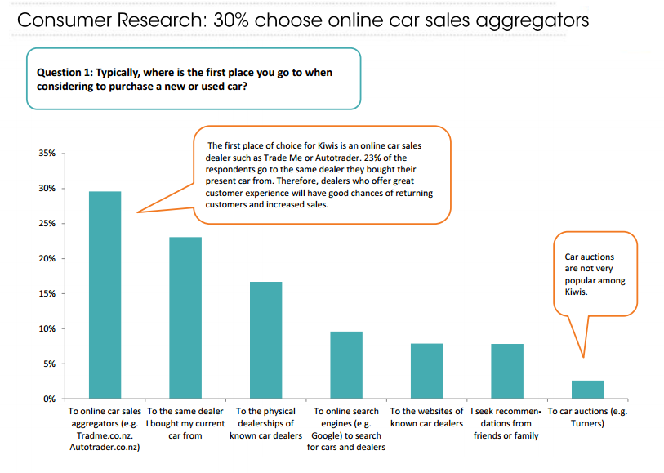

2- Economical Feasibility

This feasibility study present tangible and intangible benefits from the prefect by comparing the development and operational cost.

The technique of cost benefit analysis is often used as a basis for assessing economic feasibility.

This system needs some more initial investment than the existing system, but it can be justifiable that it will improve quality of service.

Thus feasibility study should centre along the following points:

¬ Improvement resulting over the existing method in terms of accuracy, timeliness.

¬ Cost comparison

¬ Estimate on the life expectancy of the hardware

¬ Overall objective Our project is economically feasible.



It does not require much cost to be involved in the overall process.

The overall objectives are in easing out the requirement processes. This analysis involves how it will work when it is installed and the assessment of political and managerial environment in which it is implemented.

People are inherently resistant to change and computers have been known to facilitate change.

The new proposed system is very much useful to the useful to the users and there for it will accept broad audience from around the world.

Behavioural/ Operational Feasibility

This analysis involves how it will work when it is installed and the assessment of political and managerial environment in which it is implemented. People are inherently resistant to change and computers have been known to facilitate change. The new proposed system is very much useful to the useful to the users and there for it will accept broad audience from around the world.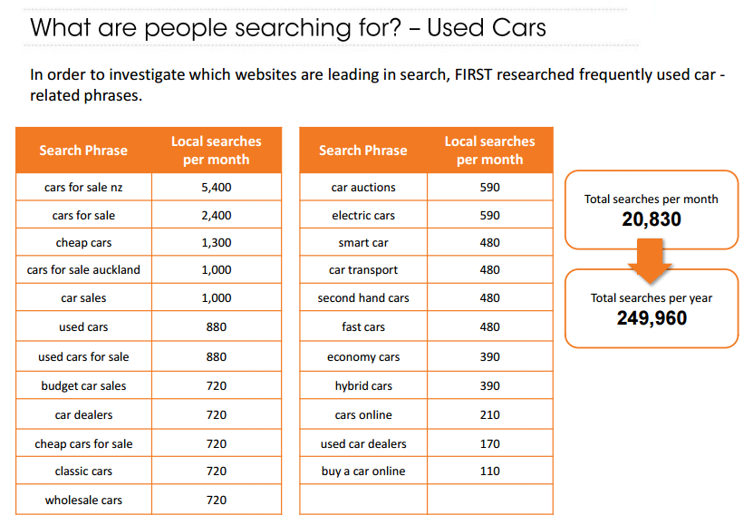

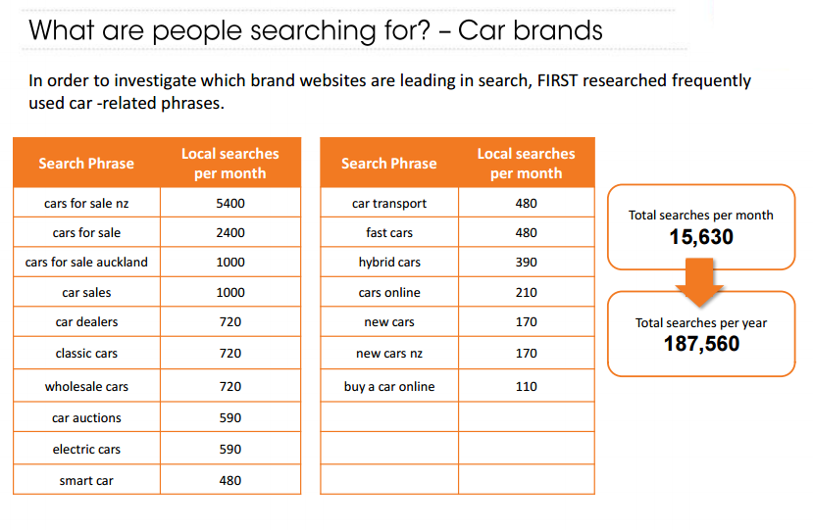

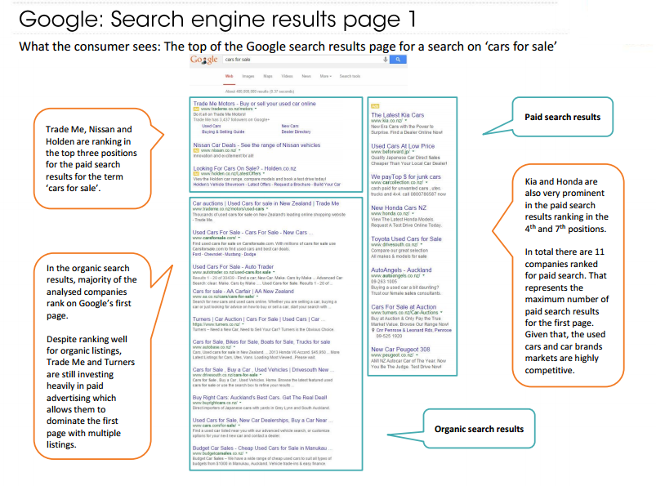

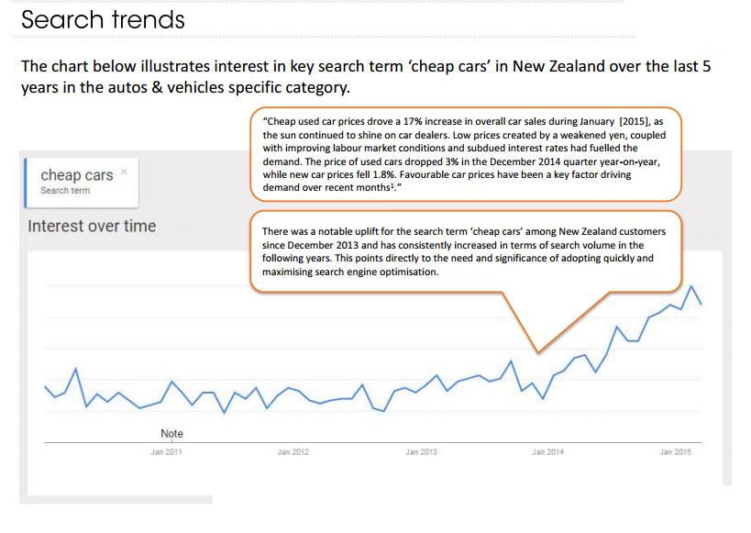*By 2015 Noticed highly increasment in the demand 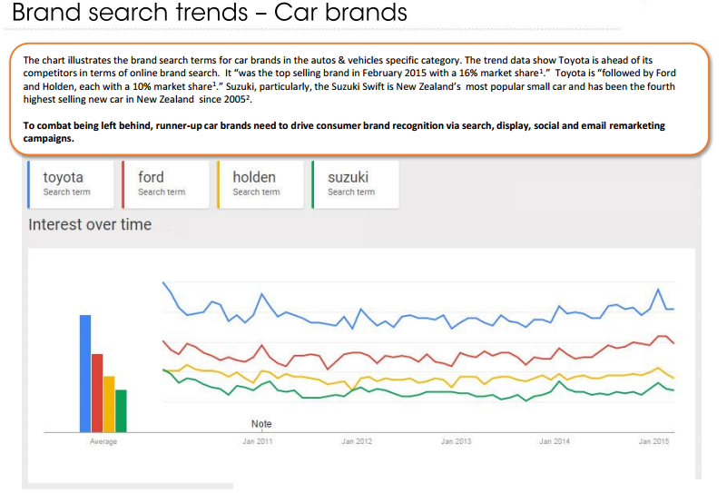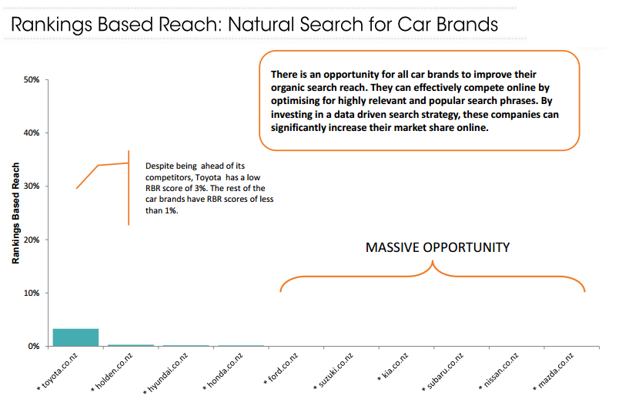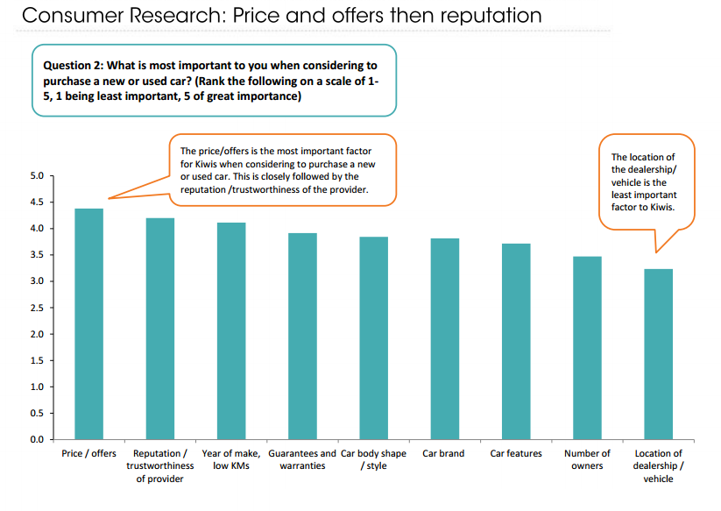

GRAPHICAL USER INTEFACES

(GUI)

Categorized into five parts:

1-Registeration and login interfaces

2-Trades

3-Sell

4-Storage

3-Chat

1. THE LOGIN AND REGISTERATION GUI’s

LOGIN

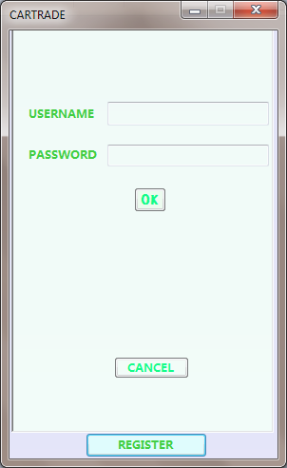

REGISTERATION

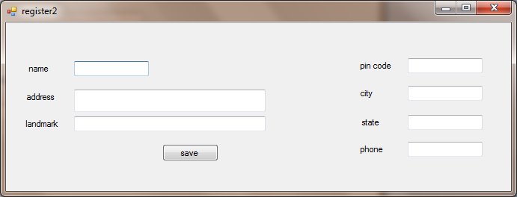

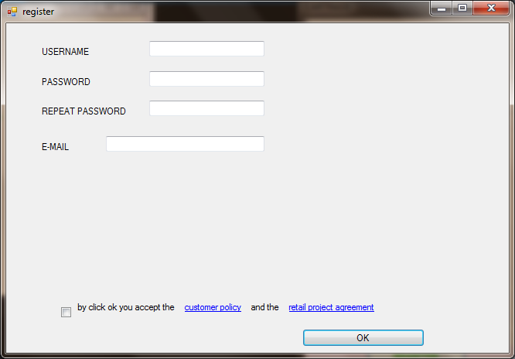

2-TRADE

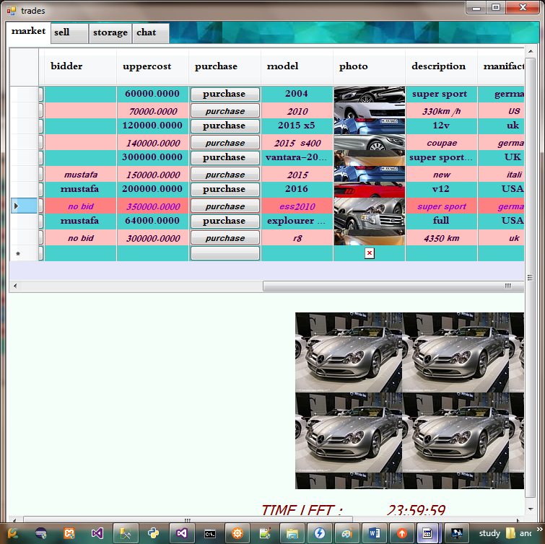

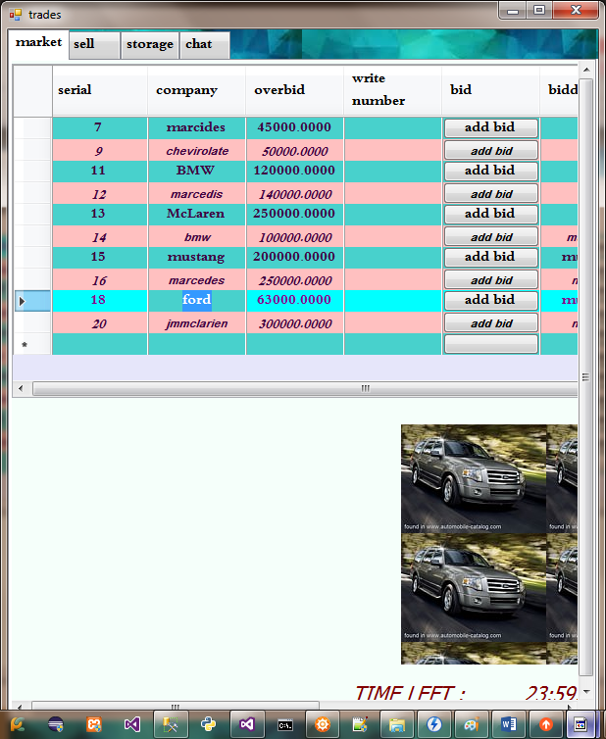

3-SELL

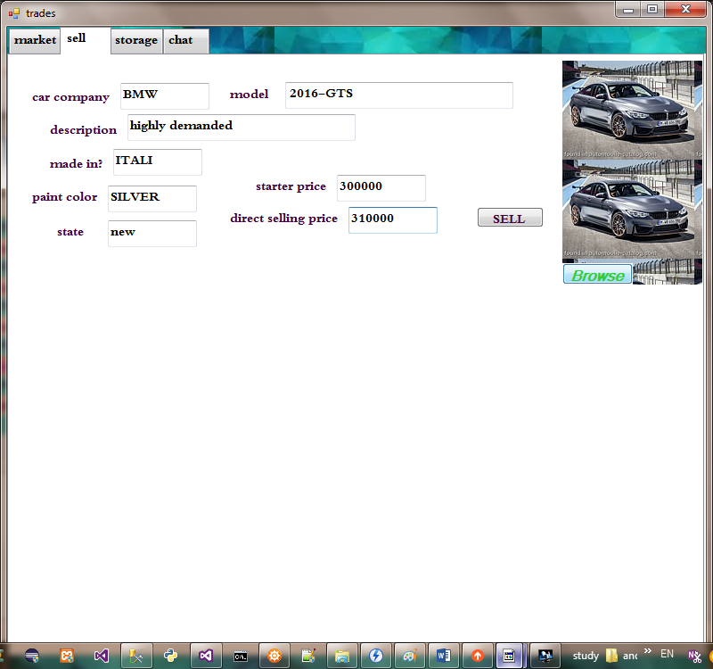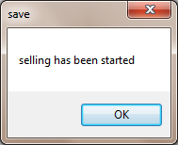

4-STORAGE

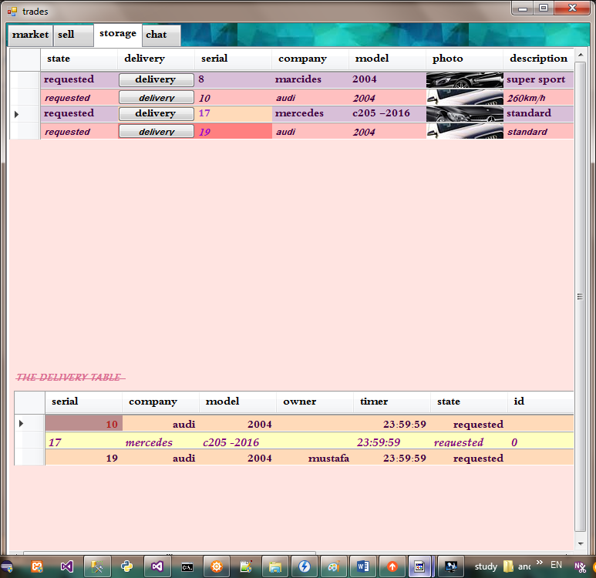

5-CHAT

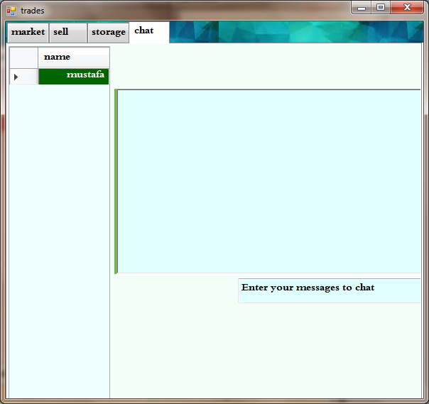

DATABASE

the database structure and its tables are shown in the following diagram

1-Accounts tables

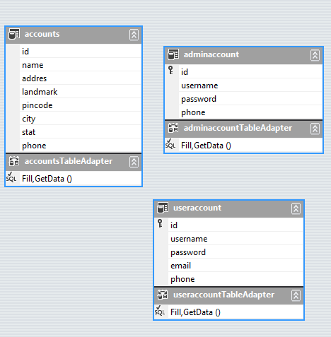

2-The progress

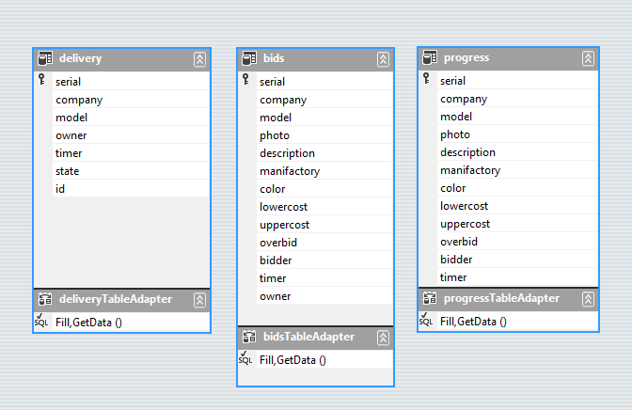

3-Inventory

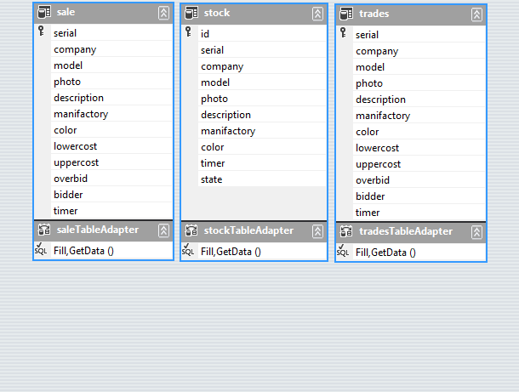

B.R.A.C.T/S

VISHWAKARMA COLLEGE OF ARTS, COMMERCE AND SCIENCE

KONDHWA BK, PUNE-411048

CERTIFICATE

This is to certify that MR. MUSTAFA TAWFIG ELSAYED of TY-BCA

have completed the academic year 2015-2016 as fulfilment of the

BCA (COMPUTER APPLICATION) COURCE.

Date:-

Project Guide Principal